**MODULE-3: HTML­­­­­­**

*-Are the HTML elements and tags the same?*

-HTML tags and elements are different, elements contain tags while tags are part of an element­­­­­.

*-What are tags and attributes in HTML?*

-in HTML, tags demonstrate the elements while attributes defines their characteristics.

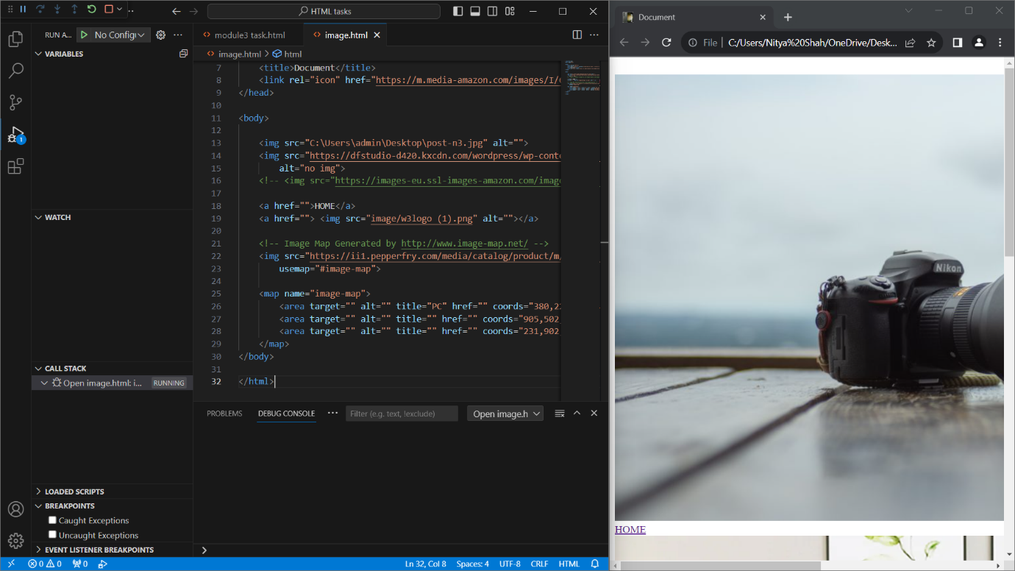

*-What are void elements in HTML? With Example.*

*-*Void elements are those which do not possess end tags. For eg:<input type=”text”>.

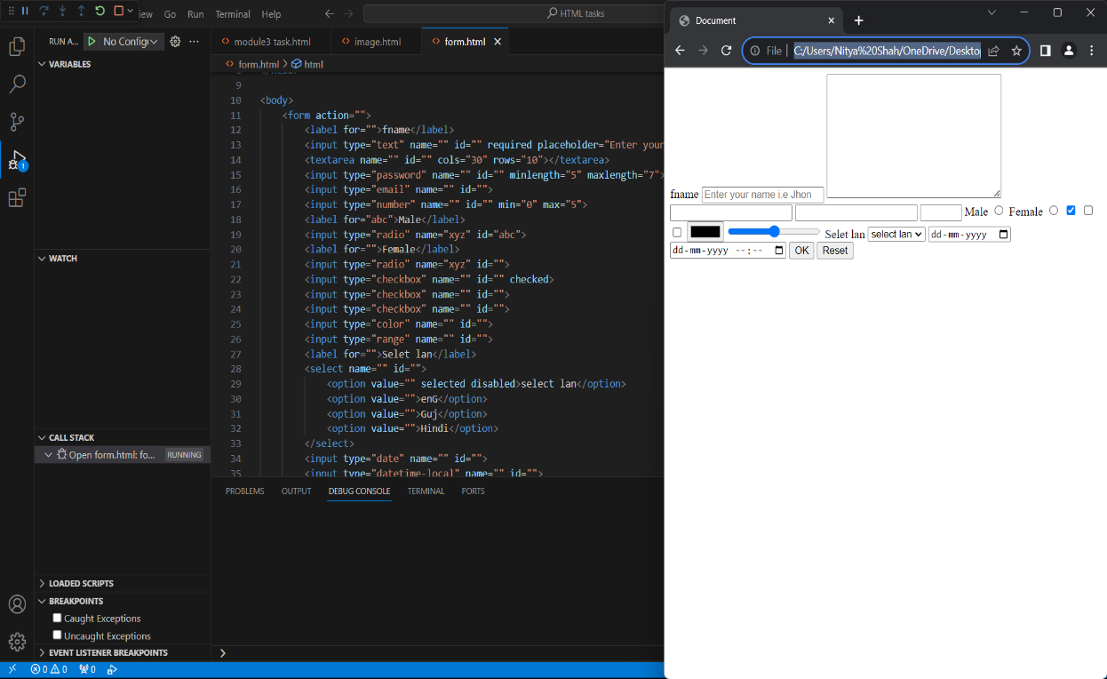

-*What are HTML Entities? With Example.*

-An HTML entity is a piece of text that begins with an ampersand ( & ) and ends with a semicolon ( ; ). For eg: &apos, &cent.

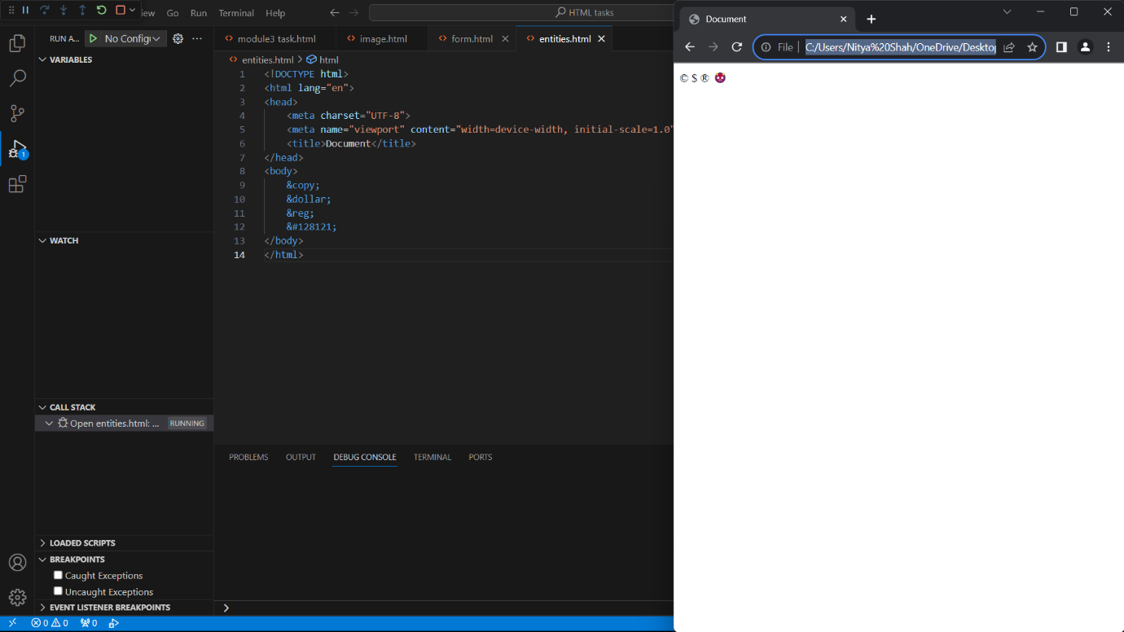

-*What are different types of lists in HTML? With Example.*

-There are three types of lists in HTML: Ordered list, unordered list, definition list.

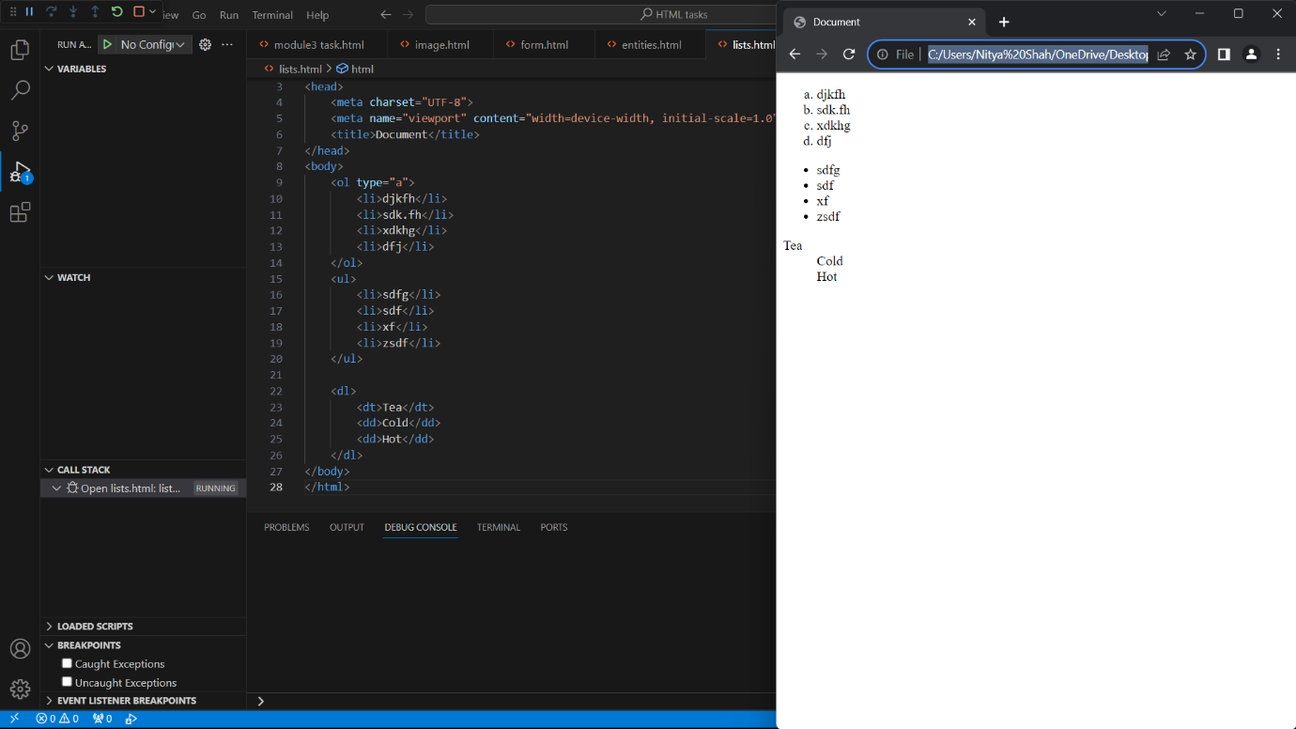

-*What is the ‘class’ attribute in HTML? With Example.*

*-*The class attribute is used to specify one or more classnames to elements.

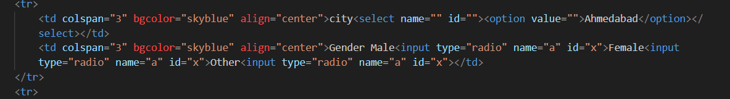

-*What is the difference between the ‘id’ attribute and the ‘class’ attribute of HTML*

*elements? With Example.*

-The ‘id’ attribute is unique and can be applied to only one element while class attribute can be applied to numbers of elements.



-*What are the various formatting tags in HTML?*

-The tags used to give special type of design to elements are called formatting tags.

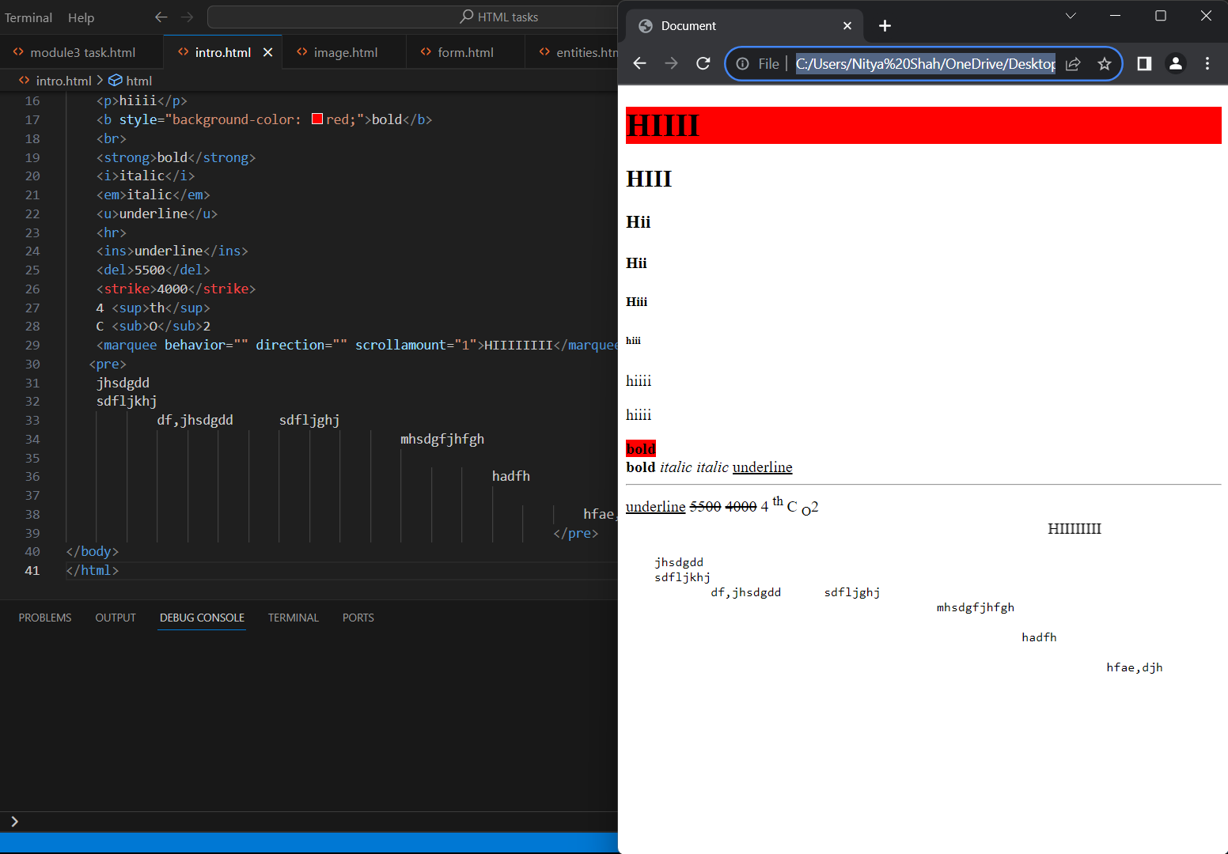

-*How is Cell Padding different from Cell Spacing? With Example.*

-Cell Padding is to give space within the cell’s border while cell spacing is giving space outside cell’s border between two adjacent cells.

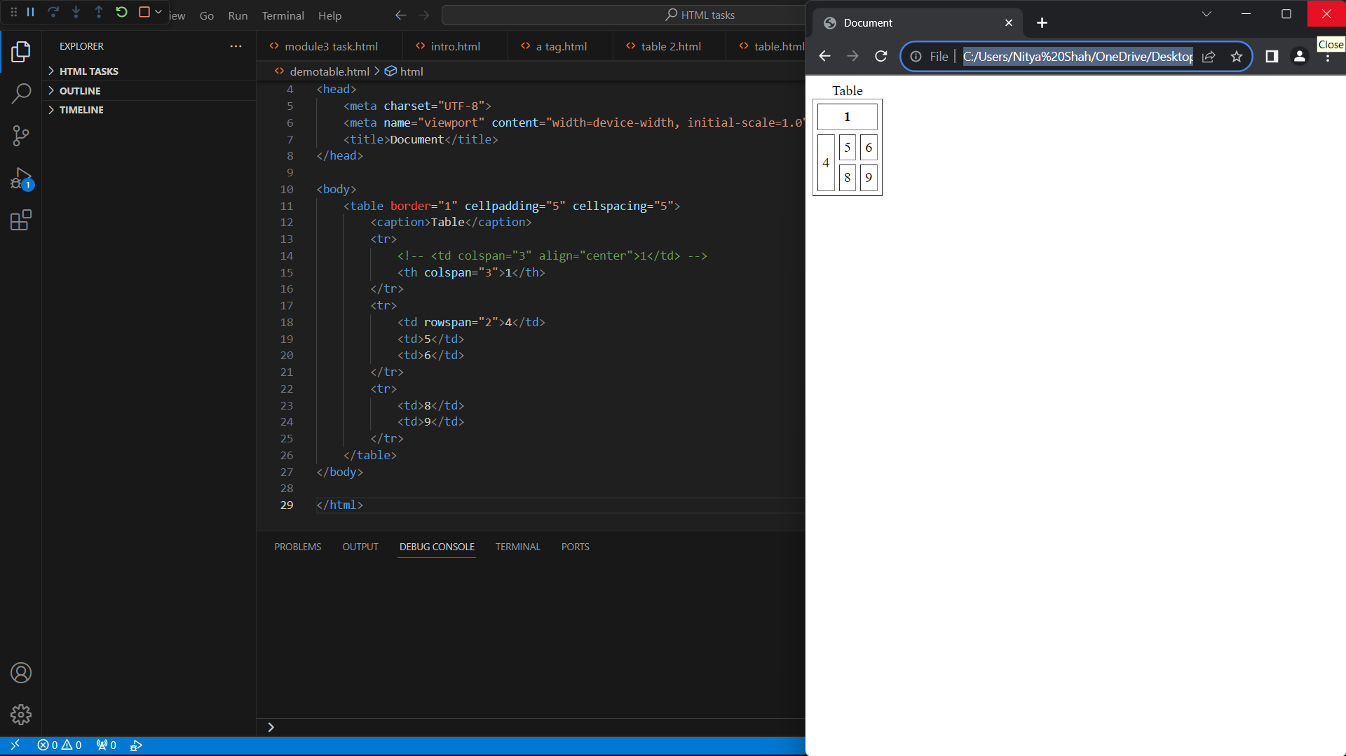

-*How can we club two or more rows or columns into a single row or column in an HTML*

*table? With Example.*

*-*To merge a row we may use the attribute rowspan (like rowspan=”6”) which merges six rows, similarly to merge columns we may use the attribute colspan (like colspan=”5”) which merges five columns.

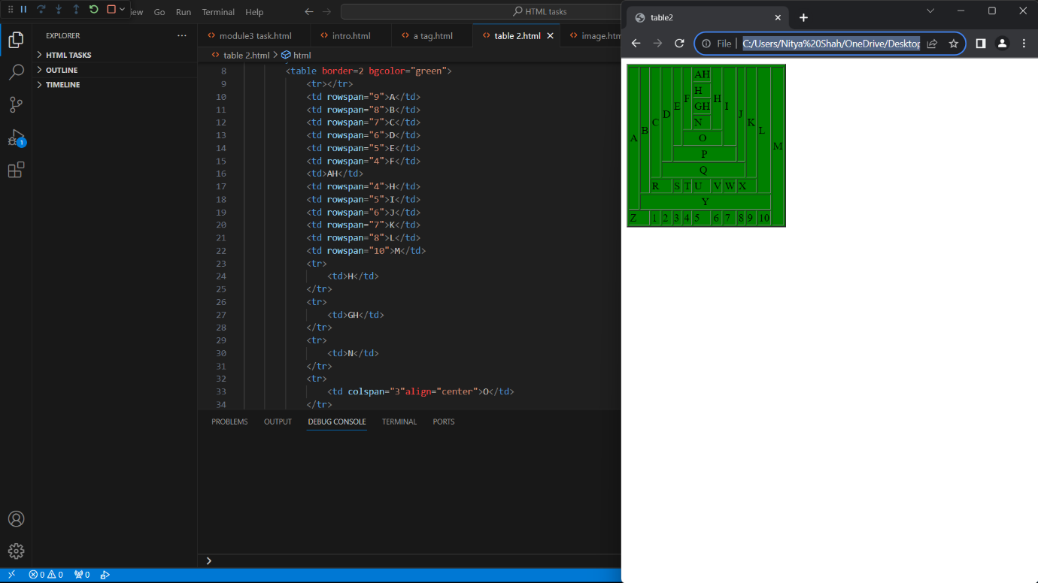

-*What is the difference between a block-level element and an inline element?*

*-*A block level element always begins with a new line and you can adjust it’s width while an inline element does not begin with a new line and even you can’t adjust it’s width.

-*How to create a Hyperlink in HTML? With Example.*

-Make use of anchor tag to create a link. For eg: <a href=”link”>Name of hyperlink</a>

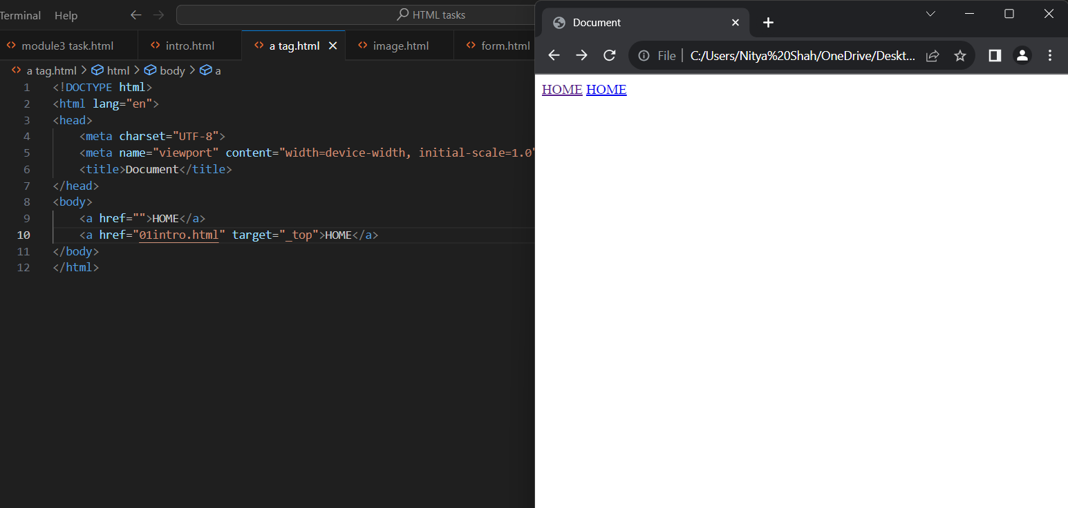

-*What is the use of an iframe tag? With Example.*

-It is used to import any content like location, video, or image from an external site.For eg: <iframe src="https://www.w3schools.com" title="W3Schools Free Online Web Tutorials">

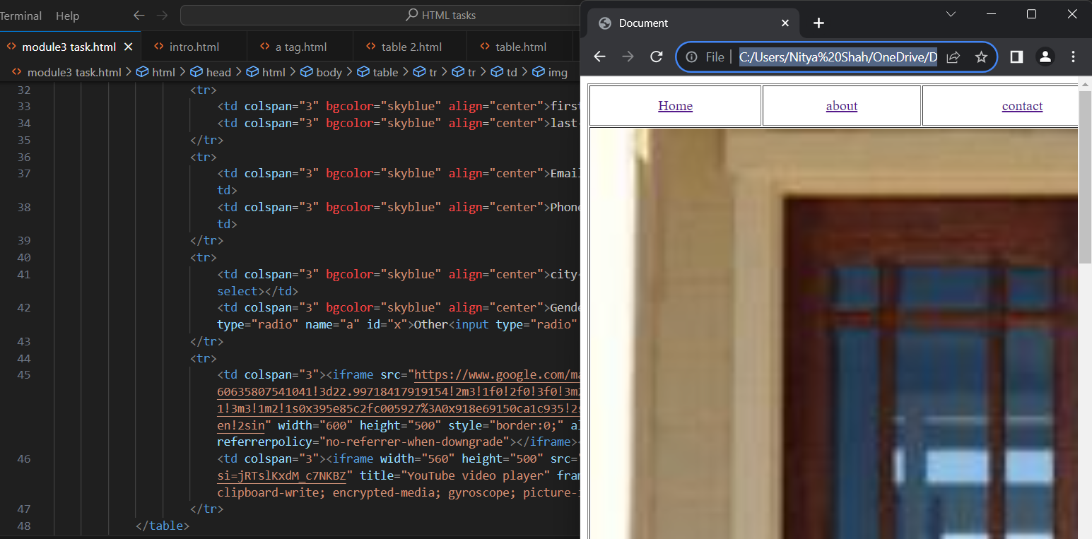

-*What is the use of a span tag? Explain with example?*

*-*Span tag is used to cover a content to apply specific styles to it.For eg: <div></div>

-*How to insert a picture into a background image of a web page? With Example.*

-We may use the background attribute in the body tag to bring the image in the background. For eg: <body background=”image link”></body>

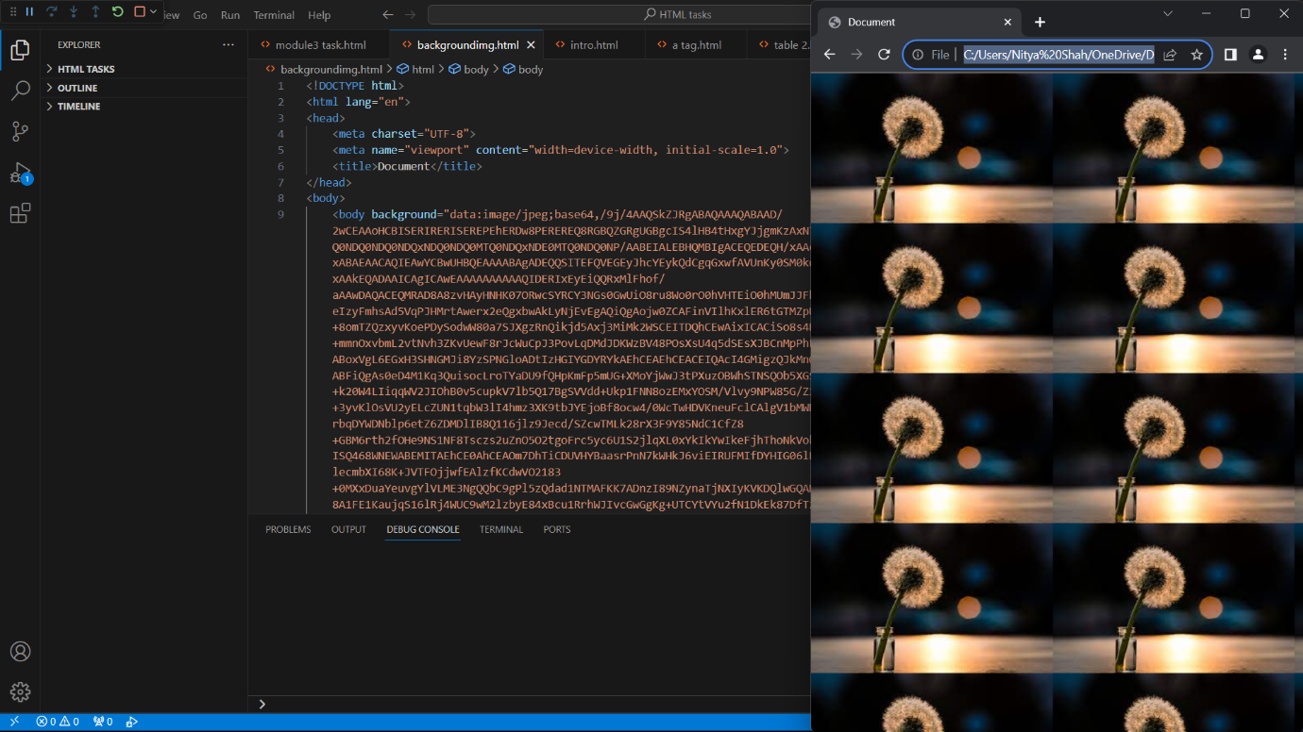

-*How are active links different from normal links?*

-Active links take you directly to the linked pages while normal links may be directed or broken.

-*What are the different tags to separate sections of text?*

-We may use break tag <br> or paragraph tag <p> to separate sections of text.

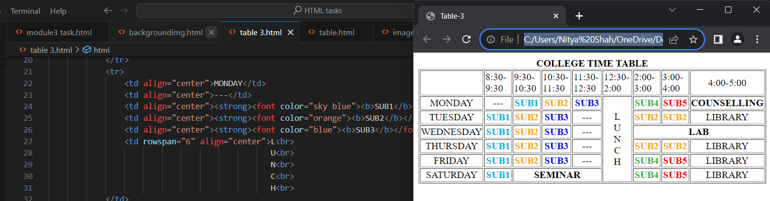

*-What is SVG?*

-SCALABLE VECTOR GRAPHICS.

*-What is difference between HTML and XHTML?*

|  |  |
| --- | --- |
| **HTML** | XHTML |
| -Tags aren’t extensible. | -Tags are extensible. |
| -Tags are not case sensitive. | -Only lower case letters are allowed. |
| -Overlapping tags. | -No overlapping tags. |

*-What are logical and physical tags in HTML?*

*-*Logical tags define purpose or function of tags while physical tags define appearance or style of the tag.

-*What are the new tags added in HTML5?*

*-* Tags like video, audio, article etc. were added in HTNL5.

*-How to embed audio and video in a webpage?*

*-*